Q&A with Olivia Blatch
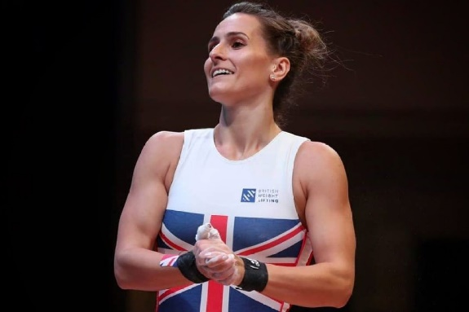

Since going into lockdown, we have caught up with one of our elite athlete Olivia, to see how she’s been doing and keeping fit during this time.

Q1. Are you able to train at home?
- Sort of! I was very lucky to be able to borrow a bar and some plates from my home club Europa. But finding a platform to lift on that doesn't break has been challenging! Top tip: Don't lift on your patio if you don't want it to get cracked!
Q2. What equipment are you using?
- One female bar, some Squat racks and a set of discs up to 20kgs. I have also recently acquired some crash pads to drop weights on to!
Q3. What does your workout routine consist of?
- My workout routine mainly consists of focusing on pulls and squats to keep up my strength. Light weighted lifts with a focus on technique. Lots of accessory work and stretching. But I'm not currently on a programme so just doing what I feel like each day.
Q4. How has this situation impacted your goals?
- It feels like my goals have been thrown out of the window for 2020, especially with all the uncertainty around Gyms opening again and competition dates. However, I appreciate everyone is in the same situation and I look forward to building back up and redrafting my goals when the time is right.
Q5. What have you found most difficult during this time?
- During this time the most difficult thing is not being able to see my coach or train with my team mates. It's really hard to self-motivate all the time and can be hard to keep training without the atmosphere and support.
Q6. What have you learned?
- I've learned that slowing down a bit is no bad thing! It's allowed me to spend time on the areas that I'm weaker or should say lazier on. For example, stretching and rehab work. It's also made me realise how much I enjoy and miss Weightlifting so has renewed my enthusiasm to get back in the gym when we can.
Q7. What would be your top tips to cope with lockdown?
A. My top tips for lockdown: Don't worry about lifting heavy weights or chasing PBs. It's more important to stay safe at home and focus on the things you can do, not what you can't. Make sure you still talk to people, especially your training partners who understand the world of Weightlifting and what you are missing. Maybe have a group zoom training session together or even just a coffee Be mindful of your diet but also don't be harsh on yourself if you are losing or gaining a couple of kgs... It will all balance back out when we can train at the same intensity again.

