Defining the Shoulder Position
In Weightlifting it is common practice to hear coaches reference shoulder position in relation to the bar (e.g. "keep the shoulders over the bar"). But which part of the shoulder are they actually referring to?
The challenge with this is that the shoulder can offer a very broad reference point (e.g. Coach 1 may use the front of the shoulder joint as a reference point; Coach 2 may use the centre of the shoulder; finally Coach 3 may use the back of the shoulder (crease of the armpit).
To help make coaches more objective in their feedback to athletes, the Technical Model specifically defines the part of the shoulder that we refer to during the lifts.
In Position 1 (Start Position) and Position 2 (End of First Pull) we use the crease of the armpit as a reference point for the shoulder position relative to the bar.
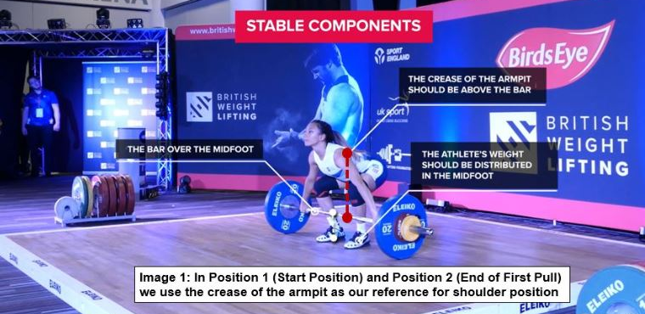
In Position 3 (Mid-Thigh) and Position 4 (Maximal Extension) we use the centre of the shoulder as a reference point for shoulder position relative to the bar.
