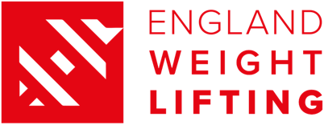

Declaration of Interest to compete at the Birmingham 2022 Commonwealth Games

Personal Information
Full Name
(as shown on British passport)
Date of Birth
(Day/Month/Year)
Full Address
(kit delivery address)

Contact number
Personal Coaches Name
& email address

Weight Category
Please highlight the CWG categories that you wish to be considered for selection in

Commonwealth Games Weight Categories | Women | 49 | 55 | 59 | 64 | 71 | 76 | 87 | +87
 | Men | 55 | 61 | 67 | 73 | 81 | 96 | 109 | +109

Kit Sizing

Please see size charts below to guide your size choices;

Leggings | T-shirt/Polo | Shorts | Track Top | Track Pants | WL Suit

Please accept this form as a statement of my intent to compete for the England Weightlifting Team at the Birmingham 2022 Commonwealth Games

Athlete Name: Athlete Signature:

Date:

Please return this form to stuart.martin@britishweightlifting.org by 17:00 on 8th January

Size Guide (Leggings, T-shirt / Polo, Shorts, Track top, Track Pants)
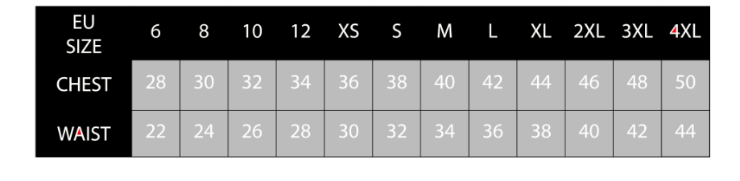
Weightlifting Suit (Sizing Charts)
Men’s Sizing Chart
Women’s Sizing Chart

