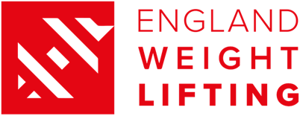

Declaration of Interest to compete at the Birmingham 2022 Commonwealth Games – Para Powerlifting

Personal Information
Full Name
(as shown on British passport)
Date of Birth
(Day/Month/Year)
Full Address
(kit delivery address)

Contact number
Personal Coaches Name
& email address

Weight Category
Please highlight the CWG Para Powerlifting category that you wish to be considered for selection in. Your preference will be taken into consideration but British Weight Lifting and CGE will have ultimate decision making authority as to the class you are nominated in should you be successful.

Commonwealth Games Weight Categories | Women | Lightweight – up to and including 61.00kg | Heavyweight – 61.01kg and above
 | Men | Lightweight - up to an including 72.00kg | Heavyweight – 72.01 and above

Kit Sizing

Please see size charts below to guide your size choices;

Leggings | T-shirt/Polo | Shorts | Track Top | Track Pants | WL Suit

Please complete kit sizes as best you can. We are aware and will be communicating with CGE that there will be tailoring demands that should be met.
Please accept this form as a statement of my intent to compete for the England Weightlifting Team at the Birmingham 2022 Commonwealth Games

Athlete Name: Athlete Signature:

Date:

Please return this form to tom.whittaker@britishweightlifting.org by 17:00 on 20th January
Size Guide (Leggings, T-shirt / Polo, Shorts, Track top, Track Pants)
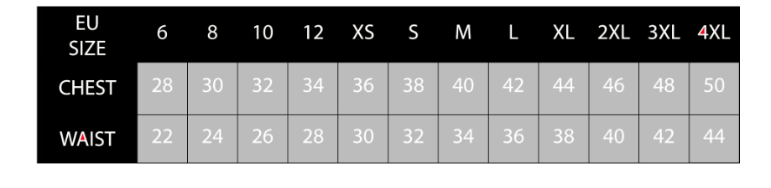
Para lifting Suit (Sizing Charts)
Men’s Sizing Chart
Women’s Sizing Chart

